Activity 1
OSMOSIS IN SIMULATED CELLS

Procedure:

1. Access the “cell homeostasis simulation” at the following website:
https://video.esc4.net/video/assets/Science/Biology/Gateway%20Resources/cell%20homeostasis%20virtual%20lab%20-%20activity/index.html

2. Press the “START” button and follow the steps of the simulation to set up 5 beakers.

3. When directed to “record in your lab notebook”, write the correct concentrations of sugar on the beakers in Figure 1 to record the solutions in the beakers (before the cells are added).

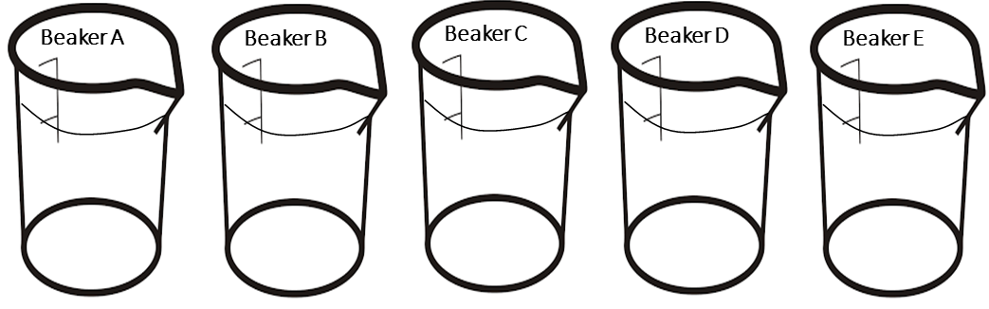
Figure 1: Five beakers from osmosis simulation.
4. Press the “CONTINUE” button. Complete table 1 and table 2 (in the Results section page) for each of the beaker set-ups as you are building them online.

Table 1: Summary of the osmosis simulation.
 | Beaker A | Beaker B | Beaker C | Beaker D | Beaker E
Cell (dialysis tubes) Contains:
(use % solute)
Beaker contains:
(use % solute)
Experimental
or
Control group

5. Before you continue in the simulation, make a hypothesis and identify the variables in this experiment.
Make a hypothesis about the net movement of water for each beaker. Please note that the sugar in this simulation cannot move across the dialysis tubing. Indicate your hypothesis by adding an arrow to each of the beakers in Figure 1. Indicate the net movement of water by pointing the arrow into the cell, out of the cell, or use a double headed arrow to indicate no net movement of water.

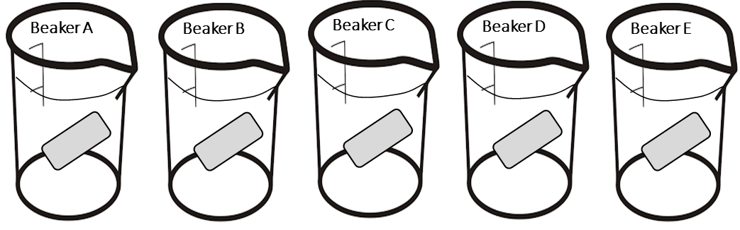
Figure 2: Five beakers and cells from osmosis simulation.
Correctly identify the following variables:

Dependent Variable: _______________________________________

Independent Variable: _______________________________________

3 Controlled Variables: _______________________________________

_______________________________________

_______________________________________

Confounding Variable: _______________________________________

6. Press the “CONTINUE” button. Record the mass of each dialysis tube as you continue the online simulation. Record these masses at the start (from step 4), and then after “24 hours” in Table 2 (in the Results sections). Calculate the change in weight for each, including a “+” sign for tubes that gained weight, or “-“sign for those that lost weight.
Please disregard the 24 hour described in the simulation and replace it with 2 hours. (The rates of osmosis would have leveled off long before 24 hours).

7. OPTIONAL- Press the “CONTINUE” button to answer a few questions.

Results:
Fill in the table from procedure # 4 & procedure #6.
Table 2: Weight of cells (dialysis tubes) from before and after simulation.
 | Beaker A | Beaker B | Beaker C | Beaker D | Beaker E
Weight of Cell (dialysis tubes) at start
Weight of Cell (dialysis tubes) at end
Change in weight

Conclusions:

- Graph the CHANGE IN WEIGHT for each of your simulated cells from Table 2 (in the results section). Make certain that you provide an appropriate Figure description, axis labels, units of measurement, and accurately graphs the data points you obtained. Remember to change the total time in the beakers from 24 to 2 hours.

- Review the hypothesis you made in procedure # 5, then compare the hypothesis to the results.
For each of the five simulated cell/beaker combinations explain what happened using appropriate terms (concentration gradient, osmosis, hypertonic, isotonic, hypotonic, diffusion, and selectively permeable membrane).

- Use the equation for rate of diffusion: Flux = P · ΔC

- Is the variable P the same or different for the cells A-E?

- What accounts for the differences in weight?

- Identify 2 more ways (environmental changes) that could alter the rate of diffusion. Explain how each change would alter the rate of diffusion.

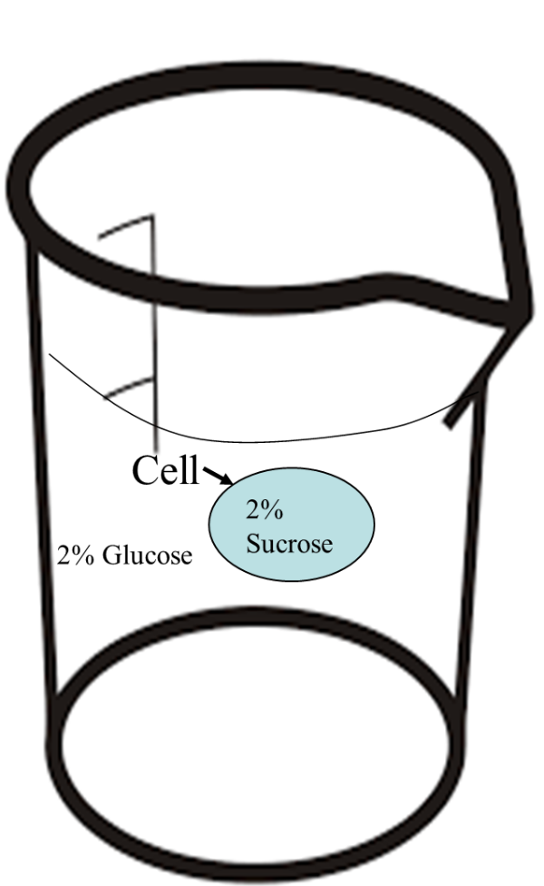
- The membrane in the cell in Figure 3 (below) is permeable to glucose but not to sucrose.
Figure 3: A simulation of a cell with 2% sucrose, in a beaker filled with 2% glucose.
  - In this example the cell is _____________ (hyper-osmotic, iso-osmotic, hypo-osmotic) to the beaker.

  - Predict the movement of:

                - Water

                - Sucrose

                - Glucose
- The cell from #4 was allowed to sit for 2 hours, see figure 4. 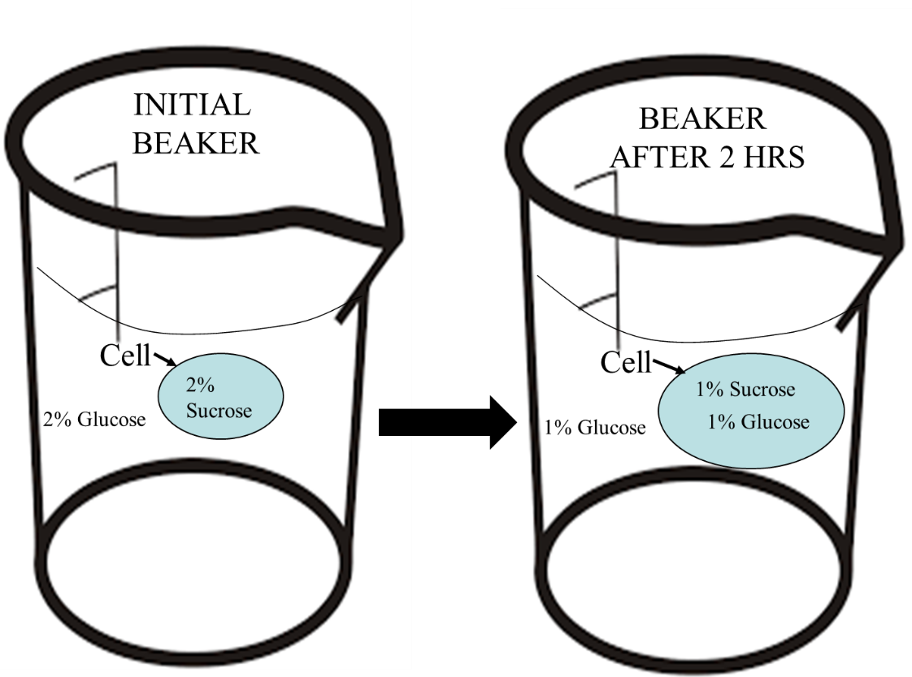
Figure 4: Initial cell has 2% sucrose and initial beaker environment has 2% glucose. After 2 hours the cell is larger and has 1% sucrose and 1% glucose while the beaker has 1% glucose.
  - The environment in the initial beaker was both iso-osmotic and hypotonic. Explain how this was possible, be sure to use appropriate terminology.

Activity 2
Osmosis in Plant Cells-
Materials:

- Potato (one)
- Ruler
- Knife
- Cutting board
- Tape
- Marker
- 2 small drinking glasses
- Tap water
- salt
- tap water
- Clock or timer
- Food scale (optional)

The procedure:
1. Make a salt solution by dissolving 2 Tablespoons Salt in 1 cup boiling water. Allow salt solution to cool to room temperature before proceeding to #2. (It is okay if you cannot measure the salt or water).
2. Cut two potato strips to be about the same size strips, each approximately 7 cm long, 1.5 cm wide, and 1.0 cm thick. Designate them as "1" and "2".
3. If a food scale is available, weigh each of the strips and record the weights in the designated part of the data table 2. (If not use the data from the accompanying video)
4. Using pieces of tape and a maker, designate two small glasses as "1 water" and "2 NaCl", and place each potato strip into the appropriate drinking glass.
5. Fill drinking glass 1 with 1 cup tap water (or enough tap water to submerge the potato strip).
7. Fill drinking glass 2 with the same amount of liquid (as used in drinking glass 1) but use the salt solution (salt water) prepared in step 1.
6. After approximately four hours, remove the strips and, if possible, reweigh them. Record the weights in the designated part of the appropriate data table 2.
7. Obtain a piece of “fresh” potato for comparison, and observe how the strips look and feel before and after soaking in the solutions. Record your observations in the results sections.

Results:
Table 1: Observations of Potato Slices after treatment with tap Water or Salt Water or no treatment.
Treatment | Observations
Potato strip in Tap Water

Potato strip in Salt Water

Control Potato strip**

**i.e. a “fresh” potato slice, cut just before you are ready to make your observations about the tap water and salt water treatments.

Table 2: weight of potato strips before and after treatment with different tonicity liquids.
Treatment | Initial weight of Potato Strip (g) | Weight of Potato Strip after 1 hour (g) | Difference in Weight (use +g or -g)
Tap Water
Salt Water

Conclusions:
Briefly explain your results. Be sure to correctly use the following terms: Hyperosmotic, Hypo-osmostic, Hypotonic, Hypertonic, Osmosis, Diffusion, Concentration gradient and selectively permeable membrane.

Activity 3
Effects of Hypotonic and Hypertonic Solutions on Red Blood Cells
In this exercise, you will observe what happens to red blood cells (RBC) when placed in solutions of varying tonicity. Blood cells are very small cells, so examples use oil immersion lens to observe the effects of these solutions.
Hypothesis: Tonicity of a solution affects the water content and structure of red blood cells.

Predictions:
RBC in isotonic solution –

RBC in hypertonic solution –

RBC in hypotonic solution –

Observation:
Watch this video of https://www.youtube.com/watch?v=A8cI6FkcG4c. Pause the video at 1:51, 242 and 3:18 to make observations and sketch the cells.
Results:
RBC in isotonic solution (1:51 in 0.9% NaCl @ 1500x) –

RBC in hypertonic solution (2:42 in 10% NaCl @1500x) –

RBC in hypotonic solution (3:18 in water @1500x) –

Activity 4
Effects of Hypotonic and Hypertonic Solutions on Plant cells
In this exercise, you will observe what happens to plant cells (elodea) when placed in solutions of varying tonicity.
Hypothesis: Tonicity of a solution affects the water content and structure of plant cells.

Predictions:
PLANT CELL in hypertonic solution –

PLANT CELL in hypotonic solution –

Observation:
Watch the video https://youtu.be/zVvHn6Sj9PQ to make observations and sketch the cells.
Results:
PLANT CELL in hypertonic solution (20% sucrose 0:00-0:23) –

PLANT CELL in hypotonic solution (water 0:24-0:38) another good video of hypotonic is (https://youtu.be/pFsty-XyLZc)-

